
ZhangDong Jan. 1967, researcher, graduated from Xi’an Jiaotong University and got his bachelor of computer science and engineer in 1988. Then he got his master’s degree for map cartography and GIS engineer in 1999. Now he is Ph. D candidate of computer network in Xi’an Jiaotong University. He is engaged in vehicle real-time navigation and embedded GIS, map data dissemination and network applications, digital watermarking.

STUDY ON ROUTE PROGRAMMING FOR VEHICLE NAVIGATION BASED ON ROUTE AVAILABILITY MODEL
Zhang Dong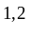 Liu Ailong Chen Tao Yang Xuewei
（1 School of Electronics and Information Engineering, Xi’an JiaoTong University, China
2 Xi’an Research Institute of Surveying and Mapping, China）
（Email: Navgrid@163.com）
Abstract：The route availability (RA) in vehicle navigation is a primary metric to measure the usability of the vehicle navigator. The routes obtained directly from traditional algorithms are often mathematically meaningful but not applicable in practice. Few researches have been reported on usability-based route analysis. This paper first introduces the concept of programming route group (RG). Then, the concept of route segment and the availability metric of each segment are defined. Upon these definitions, a route availability measurement model using probability method is presented. Based on this model, a comprehensive metric, Z, for analyzing and comparing route availability is proposed to address the dynamic change in the road network. A new route programming algorithm called Z-algorithm is designed. Comparison of the Z-algorithm and traditional route programming algorithms such as the Dijkstra algorithm shows that the Z-algorithm has a lower computing time cost and can meet the real-time requirement of navigation. Also, the route obtained from the Z-algorithm is more applicable and satisfies usability requirement of vehicle navigation.
Key words: Vehicle Navigation; Route programming; Route availability.
1 Introduction
Vehicle navigation has evolved from initially positioning and navigation services to intelligent transportation services [1], which are characterized by new features such as real-time route analysis and intelligent navigation, real-time traffic information exchange based on mobile communication networks, ITS platform, voice notification services and 3-D navigation presentation, etc.
The main purpose of the navigator is to lead drivers to their destination by voice or graphic guidance according to the computed route. The primary working flow includes destination setting, route programming, real-time navigation, re-computation when distracted from the given route and continuation of navigation. The route is the major factor throughout the whole flow. The main aspects of performance evaluation for vehicle navigator include: flexibility in looking up the destination, map display rate and visual effect, accuracy and coverage of road net, route availability, and real-time responsiveness of route programming[2], where the route availability, difficult to evaluate, is the most important metric.
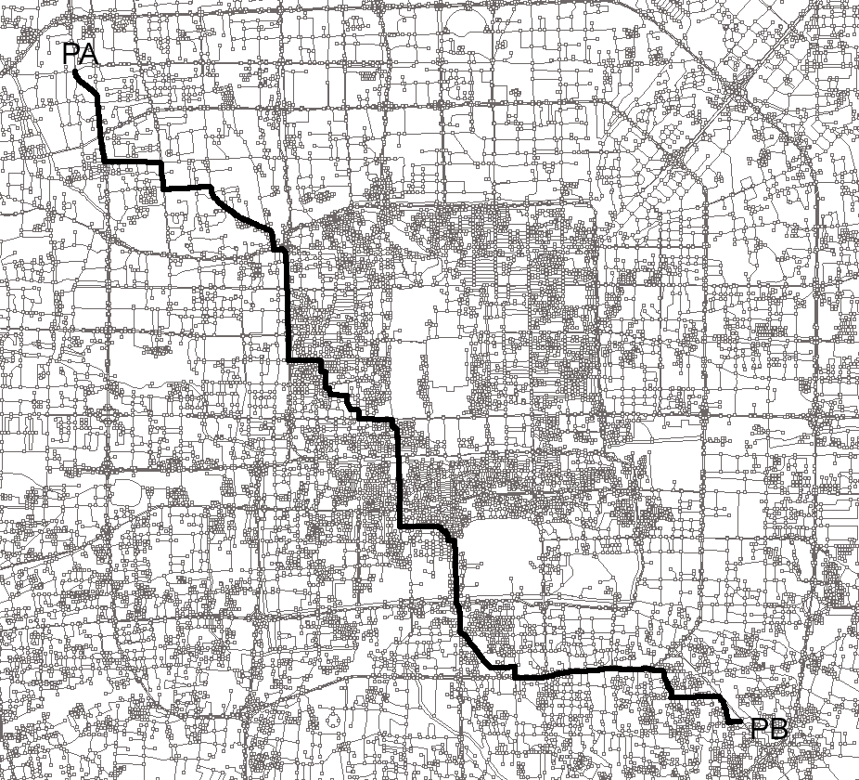
- Using common algorithm
- 14 turn-left crossings
- Through city center
- Be difficult to pass

Route Availability Issue

Less Study Works now
Fig.1 the route produced by common algorithms
Often, the computed route is not applicable in guiding the driver to the destination. Fig.1 shows a route computed by a common algorithm such as Dijkstra algorithm from the northwest corner to the southeast of the 3rd Ring Road in Beijing, China. Obviously the route is not applicable because of the 14 turn-left across the downtown area where the traffic is heavy, although the path computed is the shortest. The more applicable route is to go around the 3rd Ring Road with a longer distance.
This results in the issue of availability of the programmed route which is quite important for real time vehicle navigation. However, few systemic studies on this issue have been reported in the navigation field. Most of the studies have focused on data structure and algorithms design, such as dynamic indexing mechanism, parallel algorithm based on double buffers, optimized route programming algorithms, etc [3]. The study need for route availability include: availability definition, measurement model, effect factors, modified route programming algorithm, and corresponding availability experiments, etc.
2 Route availability model
2.1 Mathematical representation of route availability
Rationality of route programming is extremely complicated. It is very difficult to establish a route rationality model. The availability is a sub-issue of the rationality. The difficulty comes from the following reasons:
- Understanding on the route rationality depends on user’s feeling, and the same effect factor brings different feelings for different users.
- Users’ demands are quite different and varying with time.
- Rationality is directly affected by changing road and traffic conditions.
- For a complete navigation, there are several route programming operations.
Therefore, the rationality evaluation carried out by systematic analysis and direct availability measurement is difficult. What the user mostly concern is how smooth the vehicle travels during the navigation period. Therefore, we should analyze the route availability from applicable point of view.
Definition 1: programming Route Group (RG)
RG（PA，PB）=SET（RR） 1≤i≤k (1)
Here, PA is the starting point, and PB is the ending point. Because of traffic restriction and distraction from the route, the route from PA to PB needs several times, say k times, of route programming, then the actual route is a collection of k Real-time Routes (RR). RRdenotes the ith sub-route, and k=1 denotes the case of following a single selected route. Regarding the rationality and availability of the ith sub-route, the analysis results show that some segments of the route are rational and practicable and the others are not, or difficult to pass through. So it is necessary to divide the sub-route into segments as follows:
Definition 2: Segmentation of the sub-route RR:
RR（PT，PB）=SET（RR） 1≤j≤l （2）
Here, PT is the position when distracting from the selected route; RR indicates that RR is composed of l segments, RRdenotes the jth segment of RR, and l=1 denotes the route consisting of a single segment.
From the above definition, RR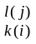(PA，PB) is used to denote that there are k programmed sub-routes from PA to PB in actual navigation, and the current sub-route, the ith sub-route, consists of l segments, and the current segment is the jth segment.
Definition 3: Route Availability (RA)
RA (PA, PB) = D / (D+ D) (3)
Here D is the distance for a vehicle to pass smoothly, Dis the distance difficult to pass through because of traffic jams, or temporary road restriction, etc. Obviously, Dand Dare dynamically changing and the data comes from:
- experience data obtained from historical statistical information for some route segments in certain period of time.
- traffic information broadcast providing real time traffic jam information.
Accordingly, the availability of the sub-route RRcan be defined as follows:
RA (RR) = D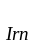 / (D+ D) (4)
Here Dis the length of the route segments within the ith sub-route which allows the vehicle to pass normally, and Dis the one that the vehicle passes abnormally.
Route availability is related to user’s demand, data organization technique, algorithms, traffic jam condition and other random events. This paper mainly studies the user demand, data organization, changing road net condition and relevant algorithms.
2.2 Availability measurement based on probability model
Definition 3 is only suitable for a statistical estimation of the route availability. In the real driving situation, availability measurement is much more complicated. The sub-route i will not be available if any segment RR cannot be passed through. Here, RG (PA, PB) ={RR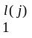，RR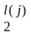，……, RR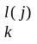}, and RR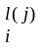={ RR，RR，……，RR} are l segments of a sub-route RR.
The availability measurement is defined by the probability that the vehicle can pass a route normally, denoted approximately with the probability model. In order to perform the measurement, the user demand model and conjunction relation among segments need to be defined according to the previous availability model.
Definition 4: Conjunction of route segments
C= C(RR, RR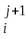) or C(RR, RR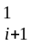) (5)
The conjunction relation among route segments, expressed as C, is actually represented by the connecting point between route segments, usually an intersection. Therefore, a route can be presented as a series of segments, separated by intersections. Let Cbe the conjunction between road segments j to j+1 in the sub-route i. When j=1, it denotes that the last segment of sub-route i is connected with the first segment of sub-route i+1.
This paper uses RBD model to analyze route RR availability as shown in Fig. 2, which is the most common sub-system partitioning method used in system availability and credibility analysis[4].
C - RR - C - RR- …… - C - RR - C

Fig. 2 Virtual RBD model for Real-time Route Partition
Here, route segment RR and connection relation Care independent. Suppose the abnormal-passing probability of route segment RRis f(RR), and that of conjunction C is f(C). Then, the route availability based on probability model can be calculated as follows:
RA (PA，PB) =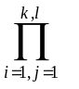(1- f(C))(1-f(RR)) (6)
How to obtain f(C) and f(RR) is complicated. Similar to D and Din Definition 3, the probability data come from: (1) integrated experience data of f(C) and f(RR) based on the historical statistical data in certain period of time, and (2) traffic condition information broadcasting systems. The navigator can receive real-time traffic jam information and adjust the weights of the road segments dynamically to ensure availability of the programmed route.
3 Route programming based on availability model
There are about 17 different route programming algorithms used currently [5]. For calculating the shortest path between two points, Floyd’s algorithm is used commonly with a time complexity of O (n) and better in practice [6]. The double Sweep Algorithm can resolve the top-k routes between one node and others. The Bellman-Ford-Moore Algorithm, though with a better time complexity, is not good in practice. A* algorithm is the most widely used heuristic algorithm. Its main characteristic is that it uses the known information combined with the distance from the current point to the end in calculating the next point. In the searching process, The most possible next point is first selected in calculation for reducing calculation times and improving efficiency. In navigation systems, the Dijkstra algorithm, brought forward in 1959, has been considered as one of the most efficient algorithms for finding the shortest path so far [7]. The shortest distances between a node and all of others in a graph can be calculated with a time complexity of O (n), in which n is the number of nodes.
The implementation of the above algorithms is mainly based on static data access and single set of topological data. The disadvantages are obvious. First, the topological computation based on single topology requires complete loading of the topological data into main memory and therefore is not suitable for navigation in a large area. Second, the algorithms can not satisfy the real-time demand of navigation because of relatively lower efficiency. Third, the algorithms cannot dynamically consider the factors such as changes in road networks and traffic regulations. Finally, the route availability is not guaranteed.
3.1 Data organization and computation in embedded navigator
In embedded navigator with limited resources, topological data must be organized into blocks [8]. There are two methods for partitioning the map into a series of blocks:
- The user-defined block: for example, we can partition the area into 16 or more blocks and construct corresponding topological data blocks to reduce data quantity in one access. But, in actual application, it is always difficult to determine the optimal block size.
- According to the scales of map: for example, we can organize the topological data according to 1:10000 mobile map, with less work in map data pre-processing. The access to the topological data block is similar to that of display map.
The above two methods are different in implementation. The former is easy to manage data but with complicated data transfer mechanism. The latter with more data blocks is convenient for data access, but the data management efficiency is lower. Both methods need to establish the relationship between adjacent blocks, and the topological data must contain information of all adjacent nodes. The part of road structure definition of the topological information is shown as follows, which involves the ID of adjacent node and block.
Struct RoadDef
{ Int16 RoadID, StartNodeID, EndNodeID; //Road ID, starting and ending node ID;
Int8 RClass, Rlength; //Class and length of the road;
Int16 RBlockAdj; // Adjacent block ID;
Int32 AdjNodeID; // Adjacent node ID;
Int32 Rxmin, Rymin, Rxmax, Rymax; //Minimum and maxmam x, y of the road;
}
Topological data needs to be classified in order to reduce the data quantity in one data access to increase the speed. The data classes include road data and background data. The background data is used for map display, and the road data is for both map display and route programming in which route programming is primary. For simplifying the topological data organization, road topological classification is corresponding to the real class of the road.
So, route programming working flow bacome clear. The computation is simple for a small area because we can put the data of all relevant blocks into the memory, including the data of all road classes.
For a larger geographical area crossing thousands kms, it bacomes difficult strongly and necessary to access through classifacation and partitioning blocks. we usually partition the area into three parts, the starting area (S area), the destination area (E area) and the middle area, as shown in Fig.3. P displayed as a bold black line denotes the selected route with the direction from the upper left to the lower right.Here just a local part is shown for clear demonstration and actual navigation is a large area.The route programming includes the following major steps: (1) The topological data of the relevant blocks and road classes is transferred according to a special algorithm. (2) in S and E areas, the topological data of all road classes is used to programm the route. (3) in the middle area, only higher classes roads are considered in calculation in order to reduce the amount of data required. This approach is also reasonable since in the large areas between S and E, the vehicle will try to run on the higher classes road.

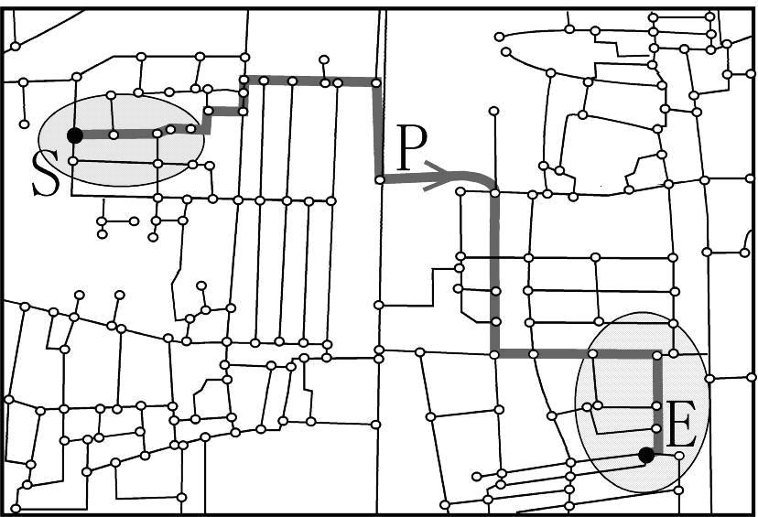
Fig.3 Route programming process and results.
3.2 The programming algorithm based on route availability
The dynamics of the route programming mainly reflected in two aspects: (1) route programming based on dynamic route availability infornmation, and (2) fast re-programming when distracting from the selected route.
The route programming algorithm involves several elements, denoted as F（PA，PB，CA，RND，RCT，RCI，RTR）. Here, CA, RND，RCT，RCI，RTR denote current point, road net data, road classification table, crossing information, route topological relationship, respectively. Real route programming can take several modes, I={I1，I2，I3，I4，I5}, corresponding to distance priority, normal pass priority, toll priority, expressway priority, and time priority, respectively. One route programming can involve one mode or combination of several modes. Each involved mode has a corresponding weight, so the weight vector R={R1，R2，R3，R4，R5 } reflects the influence of each mode. The combination of modes is represented as the follows:
RA=I·R = I·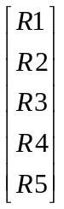 (7)
The distance L is the major criterion in selecting the next node. In real computation, the L should be adjusted according to L-Scale which is determined by the route programming modes and the availability demand. Actually, L-Scale is a changing factor of distance L in real computation.
L-Scale = RA⊕ ((1- f(C))(1-f(RR))) (8)
Here, ‘⊕’ is an integrated computation operator, maybe include comparison, plus, etc., and takes consideration of both factors: the route programming mode RAsuch as distance priority, time priority, etc., and the route segment availability RA (CA, PB). RA (CA, PB) is a special data set updated dynamically with the time and can be accessed through the link to the route segment ID.
In actual computation, we relace the distance comparison factor L with integrated comparison metric Z, and Z is then represented as:
Z=L*（L-Scale） (9)
Here: when f（RR）﹤15%, Z=L*100%; when f（RR）﹥85%, Z=∞.
Take as an example, the transformation from road segment length to metric Z zccording to route availability in Table 1.
Table 1. Road Segment Length Transform in Route Programming
Road ID | Segment class | L(length)/m | f(RR) | Time/day | Z
4729 | freeway | 2367.5 | 0.05 | 6:00-7:00pm | 2367.5
1097 | third class | 530.9 | 0.23 | 6:00-7:00pm | 653.0
8910 | third class | 789.2 | 0.74 | 6:00-7:00pm | 1373.2
3971 | fifth class | 210.1 | 0.10 | 6:00-7:00pm | 210.1

Distracting from the selected route arises at any time in real navigation, so real-time route re-programming is very important. Whole route algorithms include route programming and real-time re-programming. Fig.4 shows the re-programming process after distracting from the selected route.
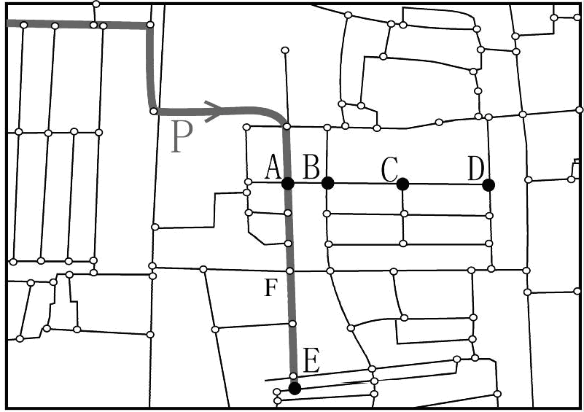
Fig.4 Re-programming after distracting from the selected route.
Here, P denotes the originally selected route displayed as the bold black line from the upper left to the lower. The speed of re-programming is very important. Suppose a vehicle distract the route P at crossing A towards B. Since crossings B、C and D are very close, perhaps B would be missed when a new programmed route is been calculated, thus a new distracting arises again. This can happen again and again and cause an endless re-programming. Furthermore, the algorithm can be modified with some skills. We can select a temporary point Fon P between A and E, and then the route programming between A and E can be reduced to that between A and F, resulting in a shorter distance and less computation which increase the computation speed. However, how to choice the mid-point F needs a lot of experiments to satisfy the real-time and availability demands. Under city roads environment, we generally choose the point F within 10 kms to current position.
An improved algorithm, Z-algorithm, based on the above metric Z is shown as the follows:
[Algorithm 4.1]
Input: Parameters {PA, PB, CA, RND, RCT, RCI, RTR}
Output：Real-time programed Route: RR
Begin：
InputDestination(CString &PA,&PB);
GetPosition(Cstring &CA); //Current position;
IndexToMem(CString &name2p5, CBitmap* Pointer1); //Get correlative map through index and find which should be put into memory;
ReadToMem(CString &name2p5, CBitmap* Pointer1); //Read to memory;
ConstructNodeSet(Struct &S1,&S2); // Set up a temporary node set S1 and a permanent node set S2;
S1=null; S2=all nodes;
L1: SearchNode(Cstring &P1 from S2); //A new extended node P1from S2;
ConstructMetric(long* Z); //Availability metric Z=L(P1)*(L-Scale(P1));
If(P1∈S1)and(Z<value in S1) then Replace P1; // Replace P1 if it has existed in S1 with smaller Z;
If (P1∈S2) then Delete P1; //Delete P1 if it is in S2;
If P2=null then RR=S1 //Get route RR;
else goto L1;
End
4 Availability experiment and conclusion
The experiments are conducted by means of an embedded navigator NAV-1 which was developed with above algorithms by our lab. NAV-1 consists of a touch screen with a 320X240 resolution, an audio output, 64MB SDRAM, and a 512MB CF storage. The CPU is a 206MHz Inter Strong ARM SA1110 processor, powered by 12V DC. It is 198mm in width, 122mm in height and 37.6mm in thickness, and weights 600g.
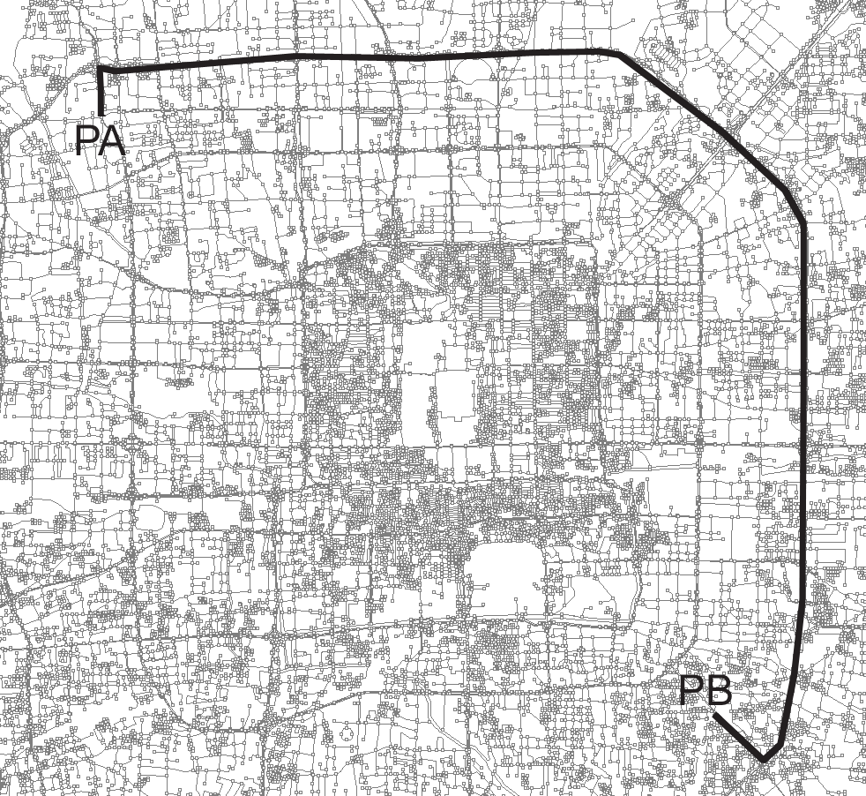
Fig.5 The route produced by Z-algorithm (R={0,1,0,0,1})
The Dijkstra algorithm is suitable for single programming mode, such as R1=1or R5=1. The route RR1 programmed goes along the diagonal direction with a shorter distance when R={1，0，0，0，0} (as shown in Fig. 1). Z-algorithm can be used for mixed modes to meet user’s mutiple demands. The route RR2 under R={0，1，0，0，1} goes along the circle road with the higher class, but the distance is larger than RR1 (as shown in Fig. 5).
The experiment was carried out at 3 p.m. Two cars equipped with navigators implementing the Dijkstra algorithm and our Z-algorithm, respectively were used in the experiment. The first navigator using the Dijkstra algorithm generated the route RR1 and the another generated RR2. using the Obviously, RR1<RR2, but we could find from Fig. 1 that there are 14 turn-left crossings for RR1, most of which are forbidden for turn left. Hence, the route was not available and had to be re-programmed many times in the real navigation. In the experiment, the route was re-programmed ten times when driving along RR1. The second car using our Z-algorithm was able to reach the destination along RR2 without rout re-programming and 45 minutes ahead of the arrival of first car. Apparently, RR2 has much better rationality and availability.
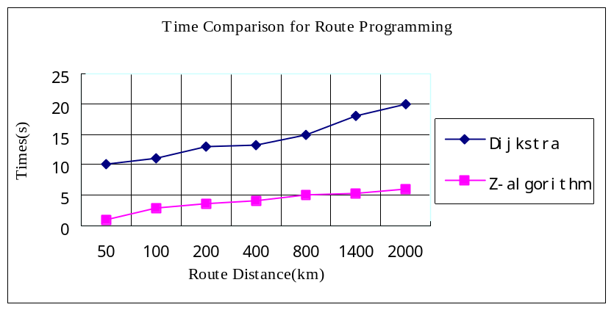
Fig. 6 Modify speed with two route computation
Fig.6 shows the comparison of route programming time. It is obvious that the optimized algorithm Z-algorithm, which can meet actual requirement, is of advantages over the traditional Dijkstra algorithm in route programming time. For example, the time of programming from the center of Beijing to Guangzhou city, a distance of more than 2000km, is only a little bit more than 5 seconds. It is necessary to point out that the cost of computation time is related to not only the distance, but also the location of destination. For example, a route destined to the suburb of Guangzhou and the one to the city center of Guangzhou will have quite different computation time costs though the distances won’t have much difference. The road condition in the city center area is much more complex and so the topological data. The computation time will be increase tremendously. This experiment does not reflect this condition.
5 Conclusion
From our experiments, we have learned that the route availability model proposed in this paper is rational and applicable. The method presented in this paper for measuring road availability is practical. Our modified Z-algorithm based on the road availability can achieve a better navigation performance for smooth passing in real situation. But we have to know that road availability is only one metric of rationality. The rationality issue is more complicated and involves more factors which have to be taken into consideration. Our future research will focus on models and algorithms which consider more factors in real route navigation, such as segments availability data collection and management.

REFERENCES
[1] Li Deren, Li Qingquan. (2002): Integrated Application of Spatial Information and Mobile Communication. Geomatics and Information of Wuhan University. Vol. 27 No.1, pp. 13-17
[2] Zhang Dong, Liu Ailong, Zhang De. (2005a): The Present Situation of Vehicle Navigation Techniques in China and the Multi-Topological Formation and Route Computing of National Navigation Map[A]. XXII International Cartographic Conference (ICC2005), ISBN:0-958-46093-0, Produced by Global Congress. Spain.
[3] Zhang Dong, Guo Jianzhong. (2005b): Multi-Topological Producing and Real Time Route Programming. Geomatic science and engineering, Xi’an, China. Vol. 25 No.2, pp. 13-17.
[4] Li Chunjiang. (2004): High Availability Research for Grid Computation. National Defence University of Science and Technology, ChangSha, China.
[5] Gao Bo. (2001): Research of Data Process Map Matching and Route Programming in Navigation. Zhen zhou University of Information and Engineering, Zheng zhou, China.
[6] Gao Yang. (2003): Research and Realization of Vehicle Navigation on PDA. University of electron science and engineering, Xi’an, China.
[7] Wu Xianghua. (2005): Navigation Map Producing and Route Research. Kun min polytechnic University, Kun min, China.
[8] Guo Jianzhong. (2005): Mass Data Display on Multi-scales. Journal of cartography institute. Zheng Zhou, Xi’an. Vol. 22 No.2, pp. 136-138.

